Criminal Justice HealthCare Data - 2018
December 21, 2018

Reach-in totals by each MCO 1/1/18-9/30/18

AHCCCS Health Plan: | Total Members who received Reach-In:
DDD | 15
MCP acute and LTC | 343
MMIC | 1,315
Care1st | 131
CIC | 1179
HNA | 42
UHCCP Acute | 318
UHCCP CRS | 1
UHCCP LTC | 2
Steward HCA-HCIC | 75
Jan-Sept 2018 Total: | 2,396

AHCCCS Pre-Release Applications:

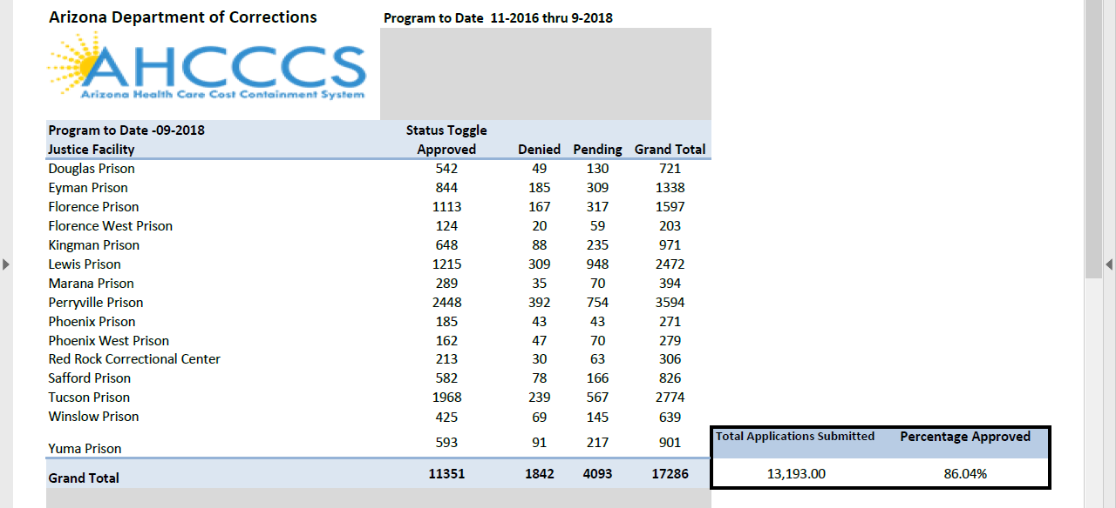

Total Dollars Spent for Incarcerated Members who were temporarily released to an inpatient hospital setting in SFY2018 (state dollars matched with Federal dollars to help offset costs):

Total Number of Unique AHCCCS Members who were incarcerated in SFY 2018:

SFY | Unique AHCCCS Members
SFY 2018 | 43924*
*Down 19% since SFY 2015

Access to Services for those involved in the Criminal Justice System:

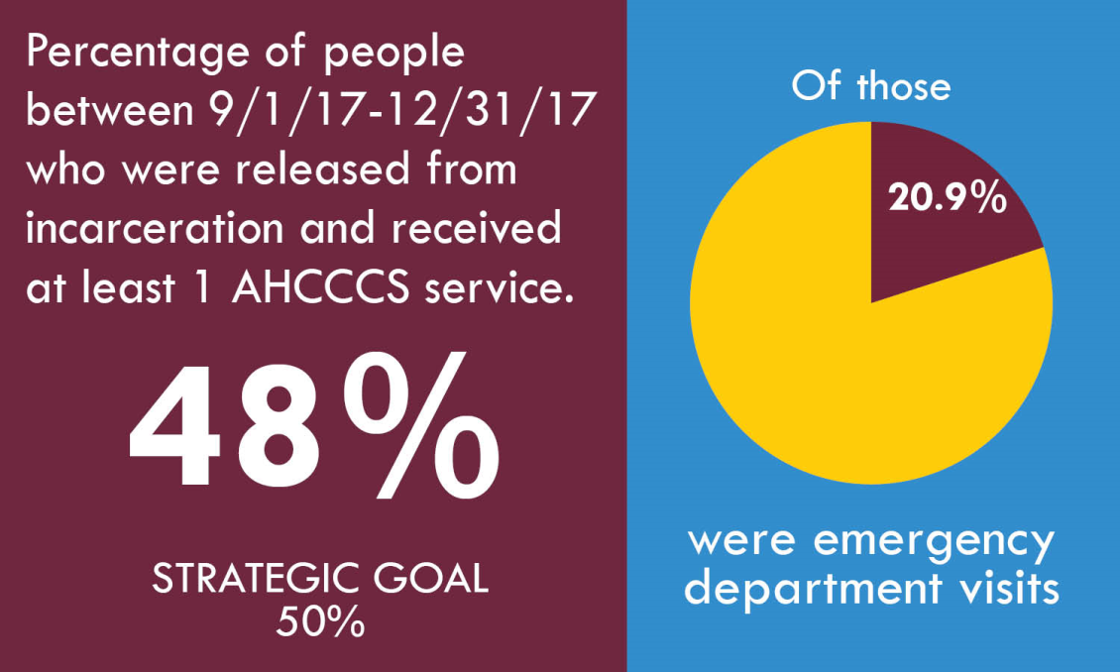

Results of September, 2018 Quarterly Justice Transitions Meeting Survey

What future topics would you like to see included during this meeting?

- more specific to a few topics to clarify and answer vs trying to cover everything in one meeting. overall meeting very informative
- I am unsure at the moment as I am fairly new to the group.
- Team Building between Counties and AHCCCS Providers. Ability to address issues with reporting coming from AHCCCS and Jails/Prisons - when member transfers from Jail to Prison, AHCCCS has an internal glitch with the dates that nullifies member state incarceration & AHCCCS then marks the member as released with full benefits until Change Form submitted to MCDU. – When MCDU corrects the error it does NOT report to providers in the same manner so reporting does not pick it up.
- actual processes which will assist people in the justice system - tools not theory
- The pre-release AHCCCS application process is very important to my program so I appreciate any topics related to this.
- Outcome Statistics
- none
- Continual updates and discussions of collaboration for treatment coverages especially in areas of cognitive programming as well as distance and teleservices.
- I would like to learn more about the reentry programs and how I could help in anyway PM
- As the seven health plans come into fruition next month, specific details as to what the plans provide as well as their similarities and differences.
- How are organizations collaborating, how can health plans address/remove barriers, how are peer support specialists and community health workers involved in reentry support?

Please provide additional comments or suggestions:

- I love this program, and all the progress that is being made on the provider side, but most counties are reticent to sharing information or respond to requests even with a signed HIPAA release provided.
- The facilitator does not respect all opinions.
- Thank you!
- none
- The work being done is to be complemented for the progressive thinking between health and criminal justice partners. Thank you for all you have done.
- Appreciate all you do :)

